Cherkassy Archeological Museum of the middle Overdnipro Land of Cherkassy National University and Town Concil Website

Software Requirements Specification template

Version 0.1

Authorized signature
Name | Title | Signature | Date of Signature
Yuriy Hlushchenko | Project Manager | YH

Revision History
Version | Description | Author | Date | Customer Approval
0.1 | Document compiled based on the provided requitements | YH | 03.11.2013
0.2 | Updated with further description of the functional requirements | YH | 11.11.2013

Table of Contents

1. Introduction 5

1.1 Purpose 5

1.2 Scope 5

1.3 Definitions, Acronyms, and Abbreviations 5

1.4 References 5

1.5 Overview 5

2. Overall Description 5

2.1 Use-Case Model Survey 5

2.2 Assumptions and Dependencies 6

2.3 Development Constraints 6

2.4 Open Points 6

3. Functional Requirements 6

3.1 <Use-case group 1> 6

3.1.1 <Use-case 1> 6

3.1.1.1 <Requirement 1 for Use-case 1> 6

3.1.1.2 <Requirement 2 for Use-case 1> 6

4. Non-functional Requirements 6

4.1 Hardware Environment 6

4.2 Software Environment 6

4.3 Network Environment 6

4.4 User Interfaces 6

4.5 Application Programming Interfaces 7

4.6 Applicable Standards 7

4.7 Performance 7

4.7.1 <Performance Requirement One> 7

4.8 Data Management 7

4.8.1 Data Volume 7

4.8.2 Data Migration 7

4.8.3 Data Retention 7

4.8.4 Data Backup and Recovery 7

4.9 Security 7

4.9.1 <Security Requirement One> 7

4.10 Usability 8

4.10.1 <Usability Requirement One> 8

4.11 Reliability 8

4.11.1 <Reliability Requirement One> 8

4.12 Installation 8

4.12.1 <Installation Requirement One> 8

4.13 User Documentation and Help System Requirements 8

4.14 Purchased Components 8

4.15 Licensing Requirements 9

4.16 Legal, Copyright, and Other Notices 9

4.17 Product Specific Requirements 9

4.17.1 <Product Specific Requirement One> 9

5. Supporting Information 9

Introduction

Purpose

The purpose of the document is to outline technical requirements of the site, its design and CMS. Provide a mock-up with the categories including a detailed description of the menu sections they are made up of. In future the may be a need for updates of the site.

Scope

This document includes functional requirements for the project

Definitions, Acronyms, and Abbreviations

<Term/abbrev./ acronym> | <Definition, description>
MySQL | Relational database management system
Joomla | Content management framework for publishing web content.
CMS | Content Management System
PHP | a server-side scripting language designed for web development but also used as a general-purpose programming language.

Overview

The final product is a website, that provides in-depth information about the history of Cherkassy Archeological museum, informs about arrangements currently taking place at the museum as well as scheduled events, facilitates communication among individuals interested in archeology and the history of the region, helps find people wishing to make an assessment of old things, which presumably may have archeological value, encourages people for archeological activity, enables people to get in touch with the administration of the museum online, ask their questions or leave comments about the museum.

Open Points

The following information is missing:
- domain name of the site;
- layout and organization of the content in some of the website pages;
- content for some menu sections

Functional Requirements

2.1 User Roles

Non-Registered Users – everyone, who opens the site. Can view the content available for non-registered users.

Registered User - users who registered, by filling out the appropriate form on the site. Registered users can post comments and have acces to content not visible for non-registered users.

Administrator – Overall project administrator with comprehensive permissions to modify/remove/add the content of the site in all its parts, manage registed users, their publications via CMS.

2.2.2 Registration

Every user can register by filling out the appropriate form , consisting of :
- User Name
- User email (must be unique)
- User password
- User password repeat entry

After clicking the “Реєстрація” link, user will be prompted to fill out the fields displayed above. On the basis of the information input, the system will check whether indicated email fulfills the requirements and in case of a positive result, send a conformation email with a unique link to be clicked on for authorisation. Upon registration completion the massage “Ласкаво просимо, (user name)” with the button “Sign out” underneath will appear.

Password reset functionality enables registered users to recover their passwords. Having entered his registration email address, user will a conformation email with the correct password.

With the User name recovery functionality, registered user, having entered his registration email,will receive an email with the appropriate information, which allows renewed usage of the information forgotten.

2.2.3 Site content will be available in 2 languages.

The content of the site as well as all its menu, category and subcategory items will be available in two languages. User will have ability to switch the language from any web page of the site.

2.2.4 Slide show mode.

Slide show mode with a four second delay between individual images will be applied to images on the home page in the section below the title and as an option available for the view of photos in the photo gallery section.

2.2.5 Recent Event/News section.

This information block on the homepage will include recent events , each comprising title and (preview) text. Optionally events can be supplemented with relevant preview image(s). The «Details» link, opening the full text of the event once clicked on, will be available in case the event can not be shown in full text in the fixed-size section set for each event on the homepage. Each event will be supplied with the link «comment» allowing registed users to post their comment(s) in the opening window under the text of the event. Unregisted users will solely have a view-only permission. Under the lowest event on the homepage, clickable links in form of numbers will be selectable, allowing to navigate to the next page with events that took place earlier in the current year, if there are any uploaded.

2.2.6 Announcements

This information block on the Homepage will include upcoming events, each comprising title and (preview) text. Optionally events can be supplemented with relevant preview image(s). The «Details» link, opening the full text of the event once clicked on, will be available in case the event can not be shown in full text in the fixed-size section set for each event on the homepage.

2.2.7 Graphical images.

Map with the location mark will be used to display the whereabouts of the museum. Double-click on the link will redirect user on the page “ Як нас знайти” . It must be also possibility to add graphical images in the photo gallery.

2.2.8 Static content

Webpages contating static static will be indicated later on in this SRS in the description reffering to them.

2.2.9 Search function.

Search by specified key words will allow users to get a quick acces to the information required. Search job will be performed across the whole website content. The number of search results will be restricted to 10. Each article containing specified key words will include title, text and preview image if available . Block for each search result must be of a fixed width and length – 2,5 cm/14сm. If the number of search results exceeds 10, link under the lowest result will emerge hiding further further search results.

2.2.10 Photo/ Video Gallery

The site will have a Photo Gallery with photos related to exhibits or events taking place in the museum which will be grouped in topics. Photos being uploaded will be automatically and resized to the maximum resolution of 800x600 pixels. It must be also possibility to add graphical images here. The site will have a Video Gallery, featuring the videos embedded from the ad hoc YouTube videochannel.

2.2.11 Comments

Registered users will be able to post comments on any news or article. The maximum number of symbols per comment is limited to 1000. For posting a comment the fileds “User Name”, “User email (must be unique)”, “User password “ will have to be filled out. Comments administrator of the site will provide will be either independent or associated with those left by registered users.

2.2.12 Common elements of all website pages.

Header, footer, manu bar with all categories and subcategories.

Site functionality

3.1 Description

The website uses Joomla, PHP and MySQL. It is based on a CMS, that enables site administrator to manage content, without changing the fixed layout of pages.

Website Pages

3.2 Homepage

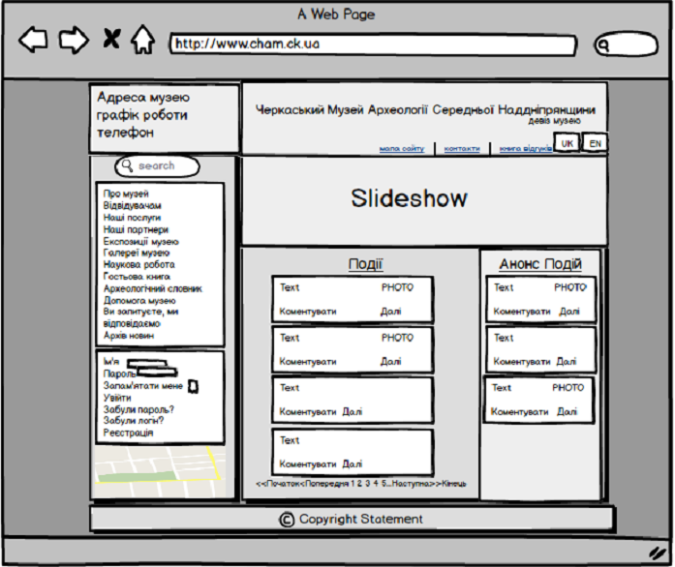

Homepage consists of the following sections – header, footer and the main body split into three blocks.

3.2.1 Header

Header includes 2 parts. The left-hand part displays visitor’s information – opening hours as well as the address of the museum. The right-hand part of the header depicts the name of the museum with the motto «Збереженість, доступність та безпека – головні принципи роботи музею »., language switch buttons and links to the website pages – «мапа сайту», «контакти», «на головну».

3.2.2 Main body.

In the upper part of the main body a slideshow of four rotating images. (for details see item 2.2.4 ) will be implemented. On the left hand section of the main body there are a search bar (for details see item 2.2.9), authorization panel with the possibility of user name and password reset/recovery (for details see item 2.2.2 ) ,general menu block and the map with location mark. The middle part of the main body will show maximum 6 (depending on the size of of the preview text) latest events (for details see item 2.2.5) and announcements of the upcoming events on the right-hand side of the main body.

3.2.3 Footer

Footer contains copyright statement and general information.

© Черкаський археологічний музей 2000-2013. При повному чи частковому використанні матеріалів посилання на сайт "ЧАМ" обовязкове.

Дизайн сайту розроблено GeekHub і модернізований "ЧАМ". Скрипти сайту розроблені GeekHub.

3.3 General Manu Categories.

General Menu categories with subcategories have a dropdown list containing the corresponding subcategories. Dropdown list will remain opened till user selects a different menu category and shift the lower adjacent menu category down. The main categories are:
  - Про музей/About Museum
  - Відвідувачам /For visitors
  - Експозиції музею/Exhibitions
  - Галереї музею/Gallery
  - Наукова робота/Scientific work
  - Гостьова книга/Visitor’s page
  - Apхеологічний словник/Archeological dictionary
  - Допомога музею/ Support museum
  - Ви запитуєте, ми відповідаємо./
  - Архів новин/News archive

3.3.1 Про музей/About Museum

Includes the following subcategories, which appear as a dropdown list when the corresponding main menu tab is clicked on:
- Музей сьогодні / Museum today
- Історія музею /History of museum
- Перспективи музею / Museum perspectives
- Наші меценати / Our sponsors
- Дарувальники музею / Givers of museum

The following are pages featuring text and photo content.
- Музей сьогодні / Museum today
- Історія музею /History of museum
- Перспективи музею / Museum perspectives

The following are pages featuring text content:
- Наші меценати / Our sponsors
- Дарувальники музею / Givers of museum

3.3.2 Відвідувачам /For visitors

Includes the following subcategories, which appear as a dropdown list when the corresponding main menu tab is clicked on:
- Як нас знайти / How to get there
- Графік роботи /Opening hours
- Колектив музею/Museum
- Наші послуги / Our Services
- Наші партнери/Our partners

3.3.3 Як нас знайти / How to get there
This tag will include the following information:address of the museum, Email, post address, contact telephone numbers, scalable map with the location mark.
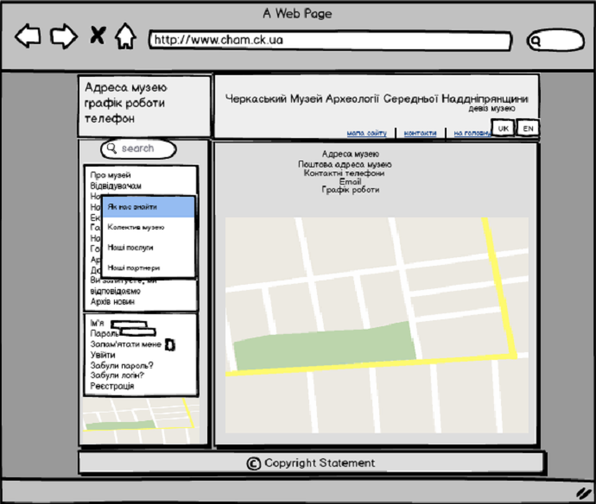

3.3.4 Колектив музею/Museum
This tag will have static text and photo content
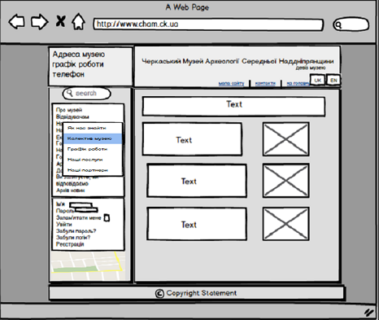

3.3.5 Графік роботи/Opening hours page will have static text content.

3.3.6 Наші послуги/Our services page will have static text content.

3.3.7 Наші партнери/Our partners page will feature text content, banners as well as HTML with the link of this site.

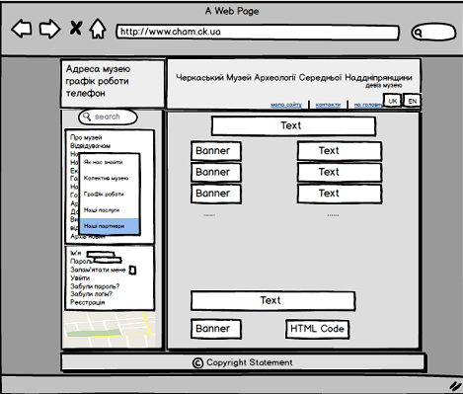

3.3.8 Експозиції музею/Exhibitions

This tag will open the page with the following content: listed names of the exhibitions, that are listed and linked to the page with the related content. Content of the page may include photo and graphic images.The number of links per one page will not exceed 10. Otherwise, links to futher exhibition list(s) will be formed beneath the lowest name of the exhibition.

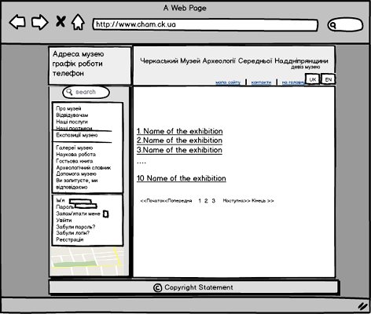

3.3.9 Галерея/Gallery will include photo and video files. Administrator will upload photo images on the site as well as embed video files from youtube ad hoc video channel. The content of the tag must be stored behind thematic groups assigned into them accordingly. To view the content of a group a mouse-click on the corresponding title will suffice. The number of links per one page will not exceed 10. Otherwise, links to futher gallery topic list(s) will be formed beneath the lowest group title.

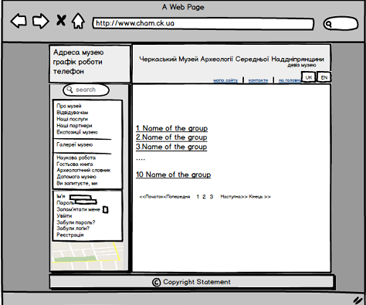

Photo previews will be placed seperatly from video preview files. A click on photo will invoke its genuine size. Photos of the following format can be possible to upload - JPG, PNG.

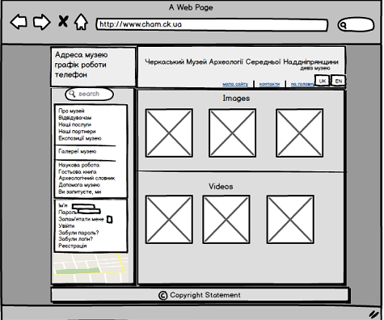

Slideshow mode can be turned on by clicking the button in the middle of the lower button row. To stop it, the same button will be used. Back and forward buttons can be also selected to navigate through the images in either direction. (for more detail see 2.2.4 )

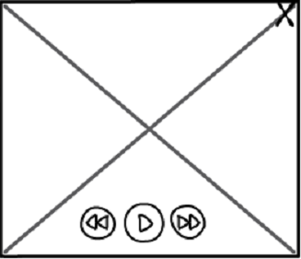

3.3.10 Наукова робота/Scientific work menu includes thre subcategories.
- Наукові статті працівників музею/ Scientic works by the museum employees

Наукові статті по матеріалах музею/ Scientific articles on the material of the museum
- Бібліотека музею/ Library of the museum

All the subcategories cosist of text content.

3.3.10.1 The tag Наукові статті працівників музею

opens the page with the authurs’ names. A click on the name opens the authors’ list of works which can be viewed by clicking the appropriate link.

3.3.10.2 Наукові статті по матеріалах музею shows a list of works. Those featuring the full text can be read by navigating to the page opening through a click on the appropriate title.

3.3.10.3 Бібліотека музею tag includes the list of books available in the musem.

3.3.11 Гостьова книга/ Guest page allows registered users post their comments. Unregistered user can only read the content of this page.(for more details see item 2.2.11)

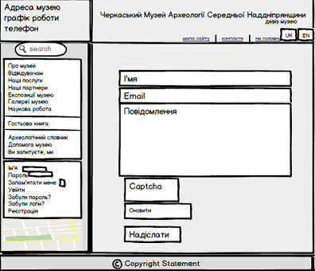

3.3.12 Apхеологічний словник/ Archeological dictionary offers a «term - definition» entries on the archeological subject area. The content is sorted in the alphabetic order to facilitate an easy search of the necessary term.

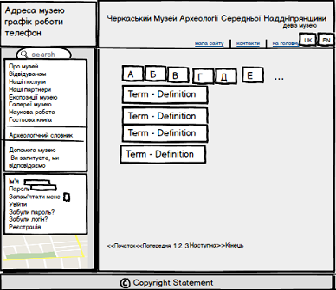

3.3.13 Ви запитуєте, ми відповідаємо/Question-Answer Page gives registered users ability to ask the administration of the museum their questions. Answers to the questions will come from administrator’s account. (For more details see item 2.2.11)
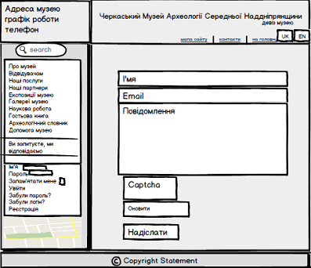

3.3.14 Допомога музею/Support museum tag gives a list of the most wanted artifacts the museum would like to extend its collection with. All the artifacts are organized in topics. To view the content of a topic a mouse-click on the corresponding title will suffice. After that a new page with the list of artifacts will open.

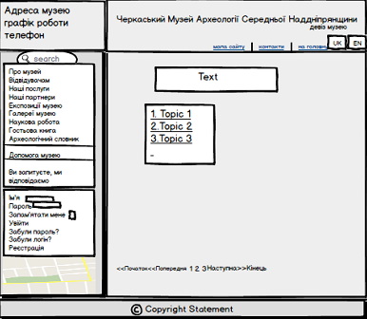

4 Back end requirements.

The administrator will use standard Joomla back end panel to manage the content of the site. He will be the only one allowed to upload images and videos. It must be possible for him to add/ delete/edit «photo/video gallery» groups and their content. Other than that, he will be able to view the list of registered users ban their registry entries delete comments should they violate the rules set by the museum administration.

5 Non-functional Requirements

5.1 Supported OS

The site should properly work on all mostly used browsers (IE 8+, Chrome, Firefox, Safari, Opera 12+)

5.2Technology constrains

The web part and server side should be written on Joomla. MySQL will be used to store the data in the datase. PHP will be used to integrate APIs for communication with the Front end.

5.3 Quality Agreement

“Сайт Археологічного музею Середньої Наддніпрянщини” project should be completely free of bugs when considered competed

5.4 Coding Best Practice

“Сайт Археологічного музею Середньої Наддніпрянщини” code has to be clean and nicely commented so that third party support vendors could follow up on maintenance and improvement work if necessary.

